Featured Poet on Paris Spoken World, Tuesday, November 12, 2020 is
Karen Melander-Magoon

She will read from her new publication,  A Year of Anguish,  A Time for Miracles,  poetry written from February to July of 2020 | 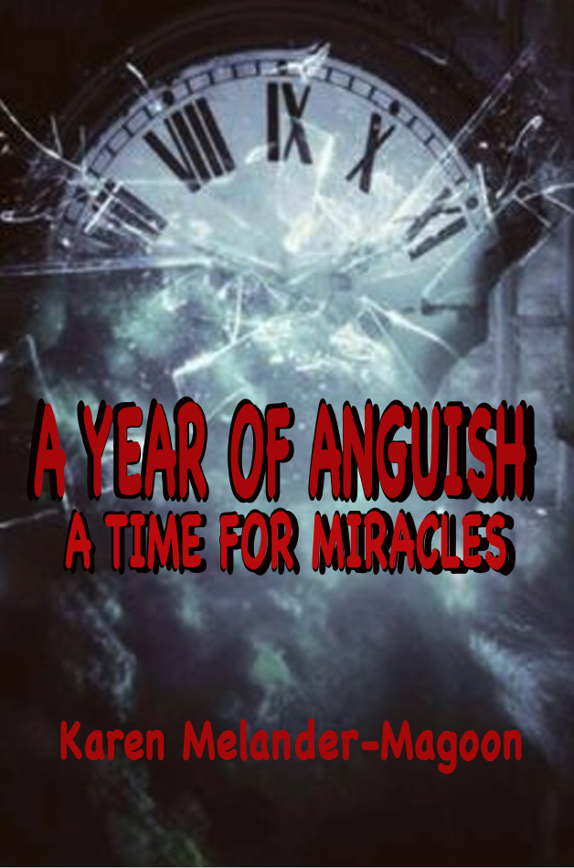 | 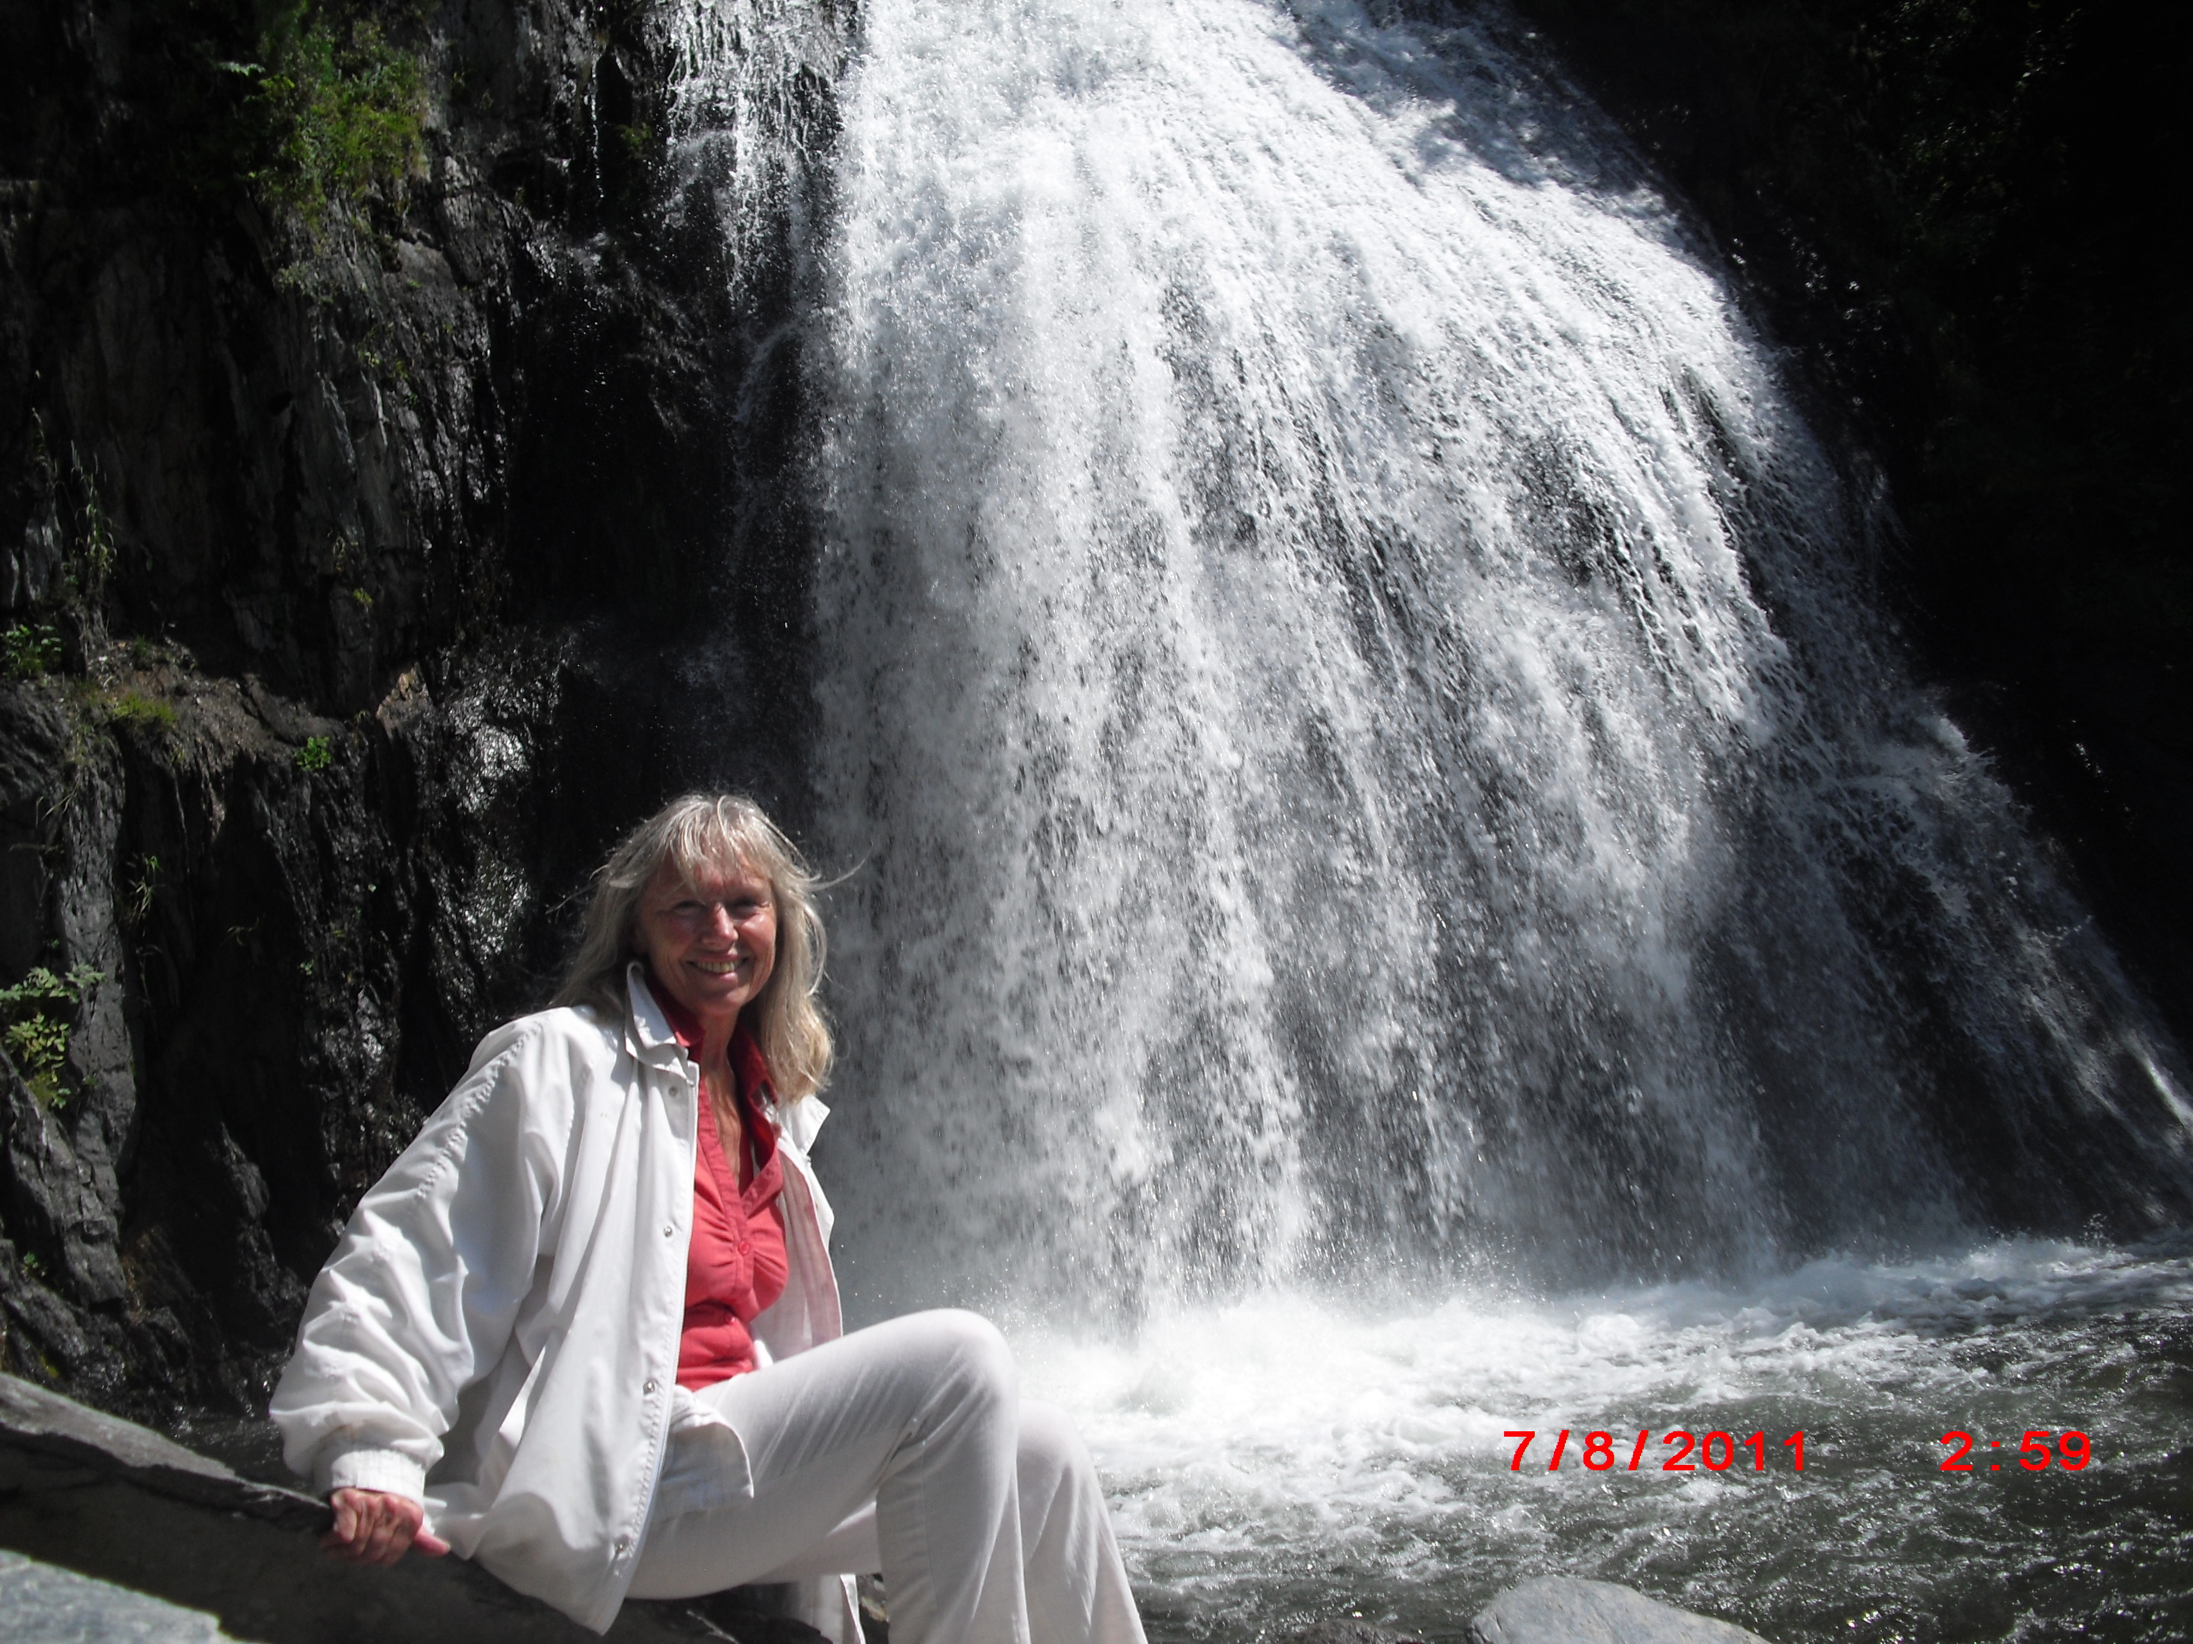  Karen in front of a  waterfall in Siberia, Russia

Karen spent much of her life singing opera in Europe (featured roles were Marguerite in Faust, Norina in Don Pasquale, Rosina in Barber of Seville, Musetta, Adele, Despina, and many other major roles in opera, operetta and musical, appearing in theaters in Berlin, Vienna, Osnabrueck, Augsburg, Dortmund and more), returning to the states to marry a vintner, Orville Magoon, renowned in the coastal world, and help run a winery, once owned by Lillie Langtry, about whom she wrote a musical: Lillie, a Musical. She brought in carménère, the last of the great Bordeaux winegrapes to be certified in California, did jazz fundraisers for the community and wrote and performed musicals about Georgia O’Keeffe and Clara Barton.

Karen earned her doctorate in ministry from San Francisco Theological Seminary as well as her bachelor of music degree from Indiana University and a master’s in education/counseling from Boston University. She continues to write poetry, songs, and musicals. Today she helps deliver supplies to a safe house for battered women in San Francisco, and hopes to best express her social activism in poetry. Above all, she tries to keep in touch with her children and grandsons during the pandemic shut down. Her new book, the earth turns, will be out next year.

